CEN 4010 Fall 2019

FAU Daily

Group 14

Mark Rothberg- Project Manager/Team leader

Marcus Golding- Scrum Master

Wayne Solomon- GitHub Master

All- Development Team

Date: 11/18/2019

History Table:

11/17/2019

Last Edited: 11/18/2019

**Product Summary**

The product’s name is FAU Daily. The major committed function that our product focuses on is posting information to the news blog page. We have tested this function and it has been approved by the Product Owner. It is very easy to post to the page and easy to navigate. The unique feature is that you can directly post to the website from the home page without the need to register. This allows users to post anonymously and to post instantly.

URL: <http://lamp.cse.fau.edu/~cen4010fal19_g14/index.html>

**Usability Test Plan**

Test objectives:

The goal is to be able to post a blog onto our home/temporary page

Test plan:

To test this we will use a separate computer to represent a “new user” to see if we can get to the website. Then, make sure that the user can see the post that have already been made. Following that, we will test to see if the user can create a post/news article using the given interface. Lastly, check to see if the created post is showing on the website.

Questionnaire form:

Answer all questions on the scale of: Strongly Disagree, Disagree, Neutral, Agree, Strongly Agree

* You were able to access and navigate through the website?
* You were able to create a post comfortably?
* You were able to see the post on the temporary site?

**QA Test Plan**

Test Objectives:

The goal is to be able to create and post a blog onto our home page

Hardware and Software Setup:

Windows and Mac OS

Google Chrome and Microsoft Edge

Feature to be Tested

Website posting feature for adding in content relating to FAU Daily news

Actual Test Cases:

1. Is the website coming up indicating that our server is working?
2. Are we able to create a post using the user interface?
3. Can we visibly see the listing on the temporary website?

Google Chrome

|  |  |
| --- | --- |
| Test 1 | Pass |
| Test 2 | Pass |
| Test 3 | Pass |
| Summary | Website in its infancy works as intended |

Microsoft Edge

|  |  |
| --- | --- |
| Test 1 | Pass |
| Test 2 | Pass |
| Test 3 | Pass |
| Summary | Website in its infancy works as intended |

**Code Review** Our coding style includes the use of html, css, php, SQL, and bootstrap.   
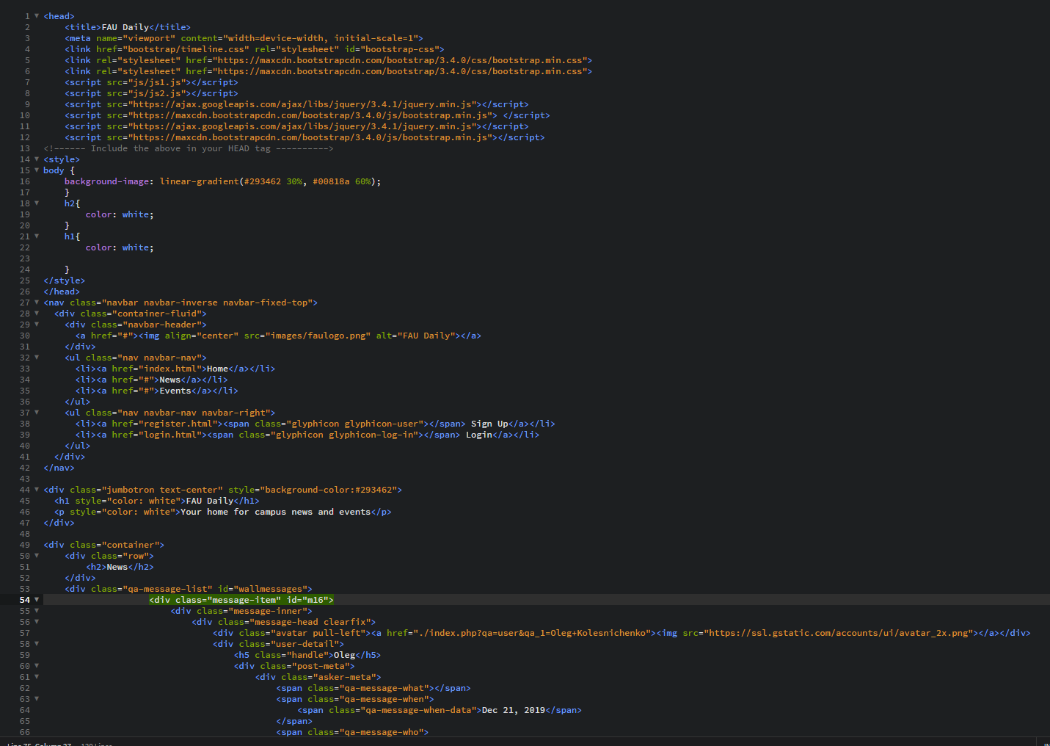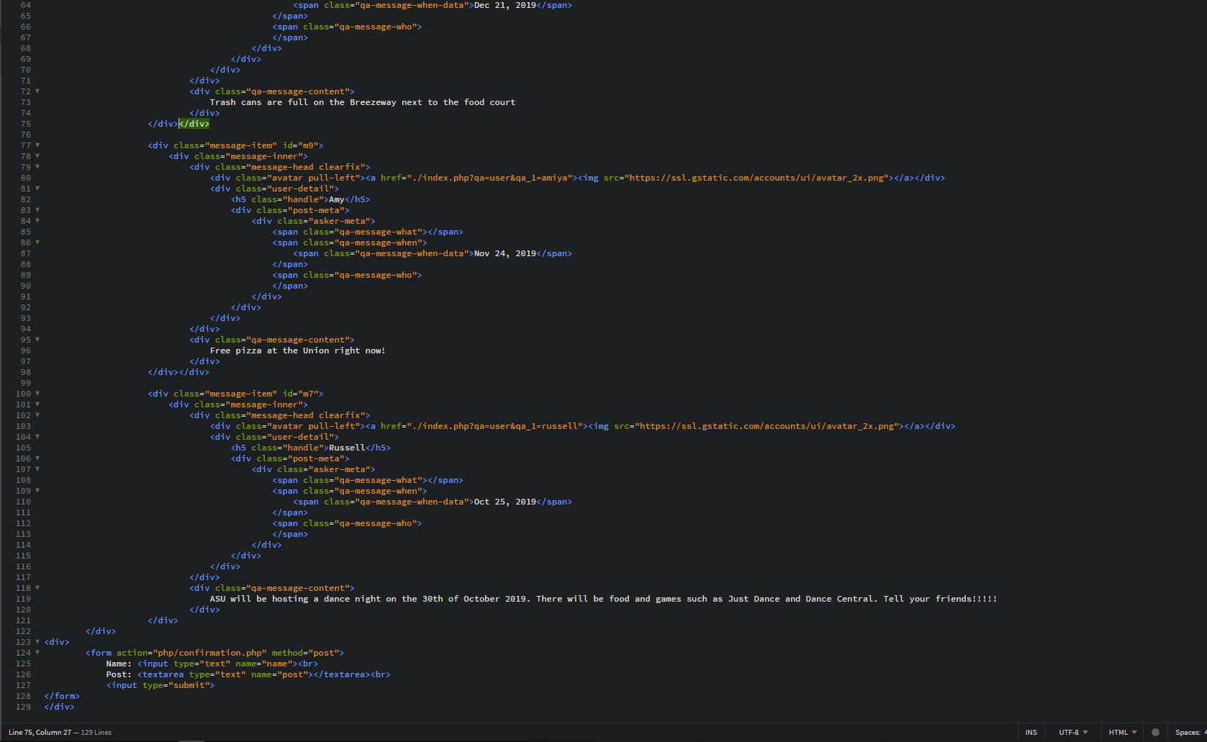

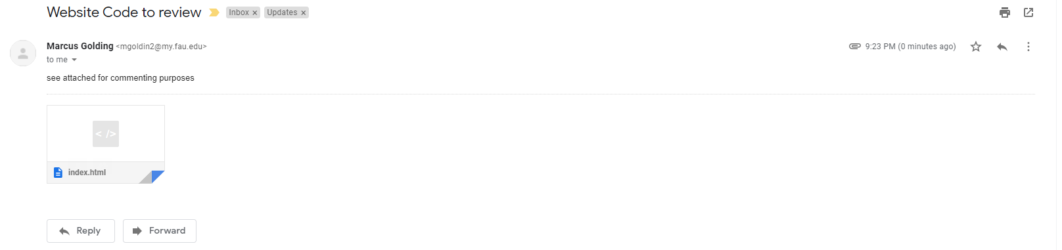

Peer Reviewed Code >

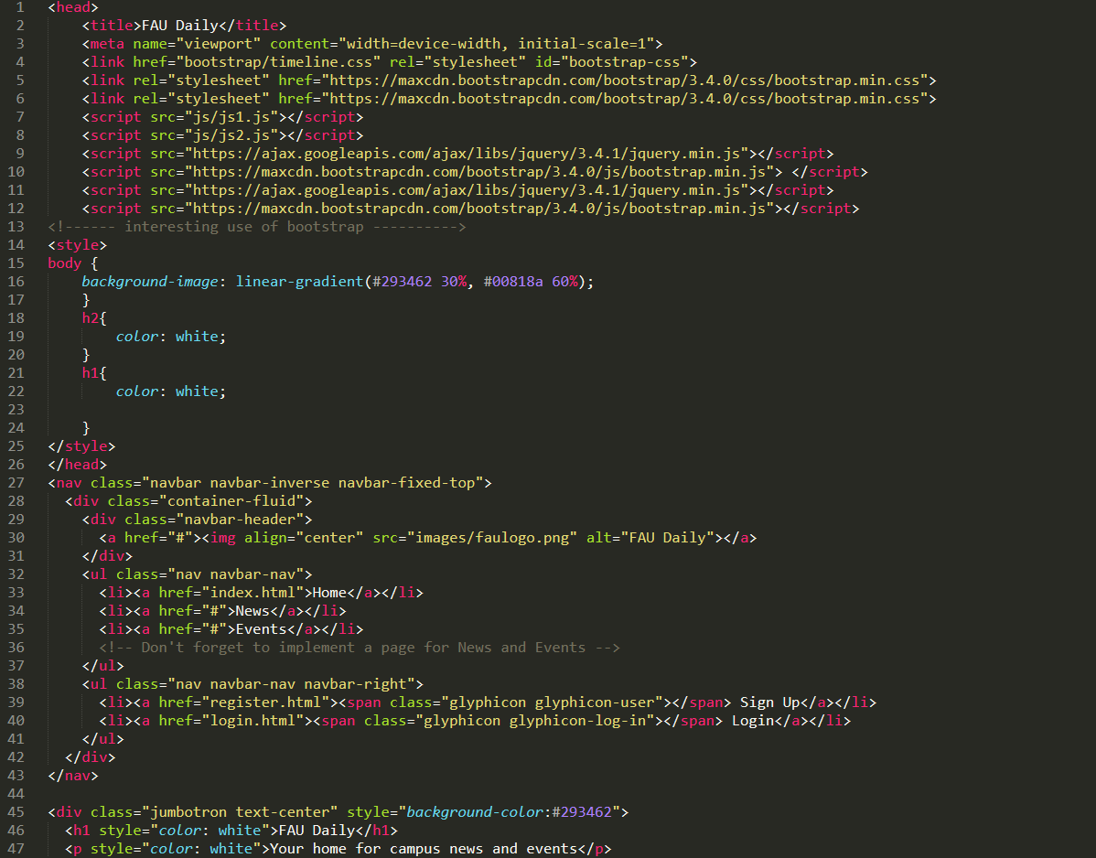

**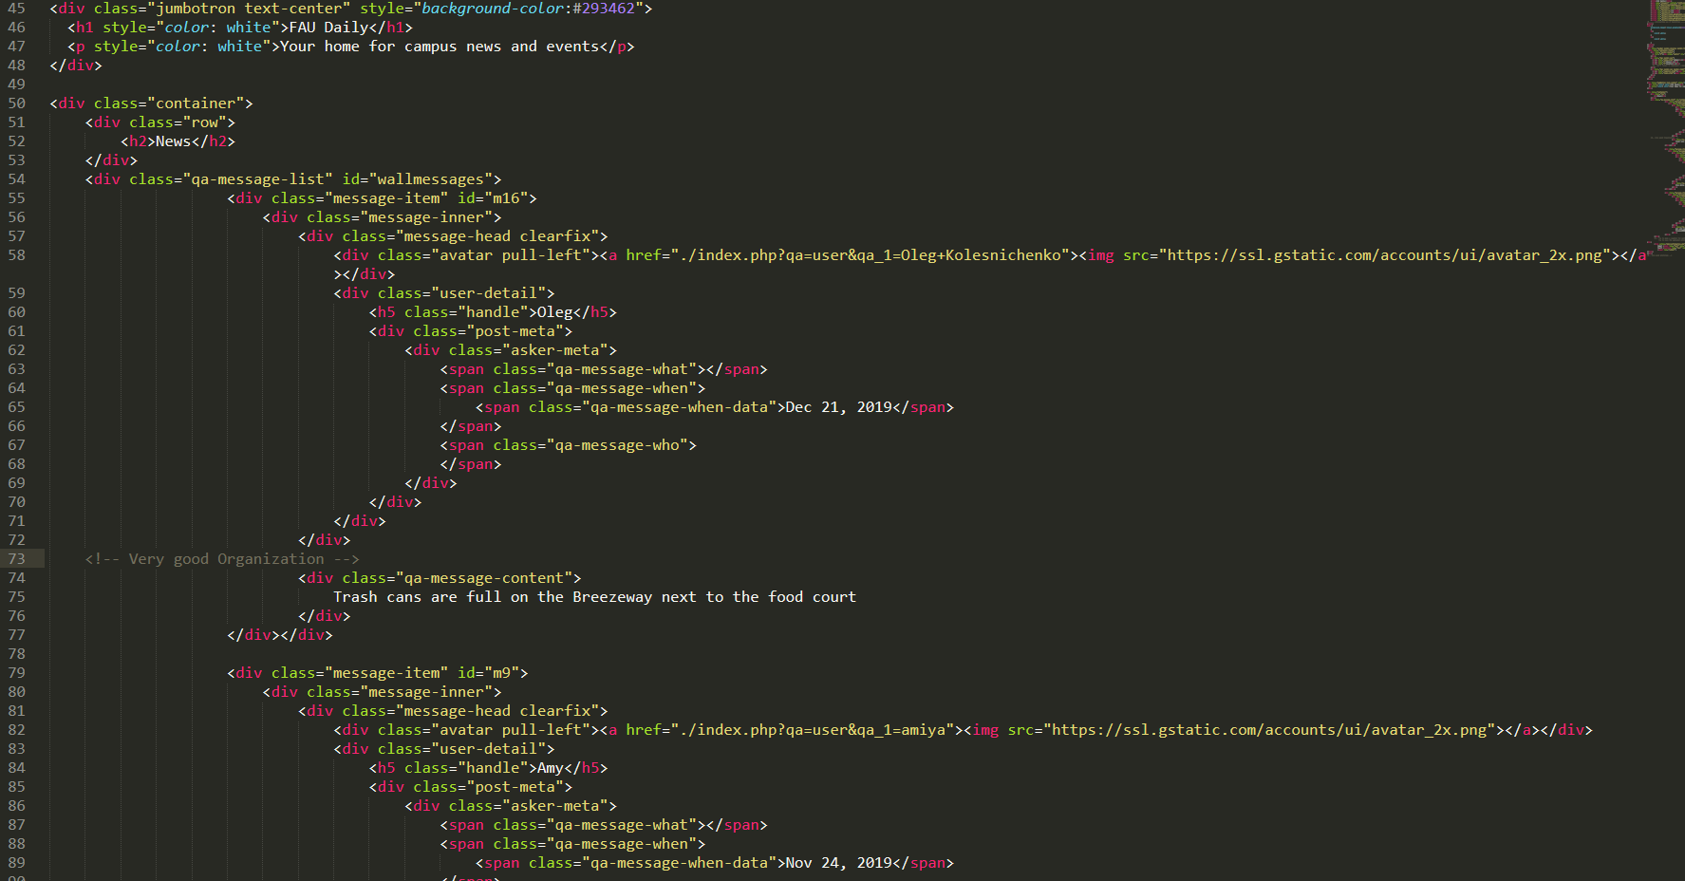  
  
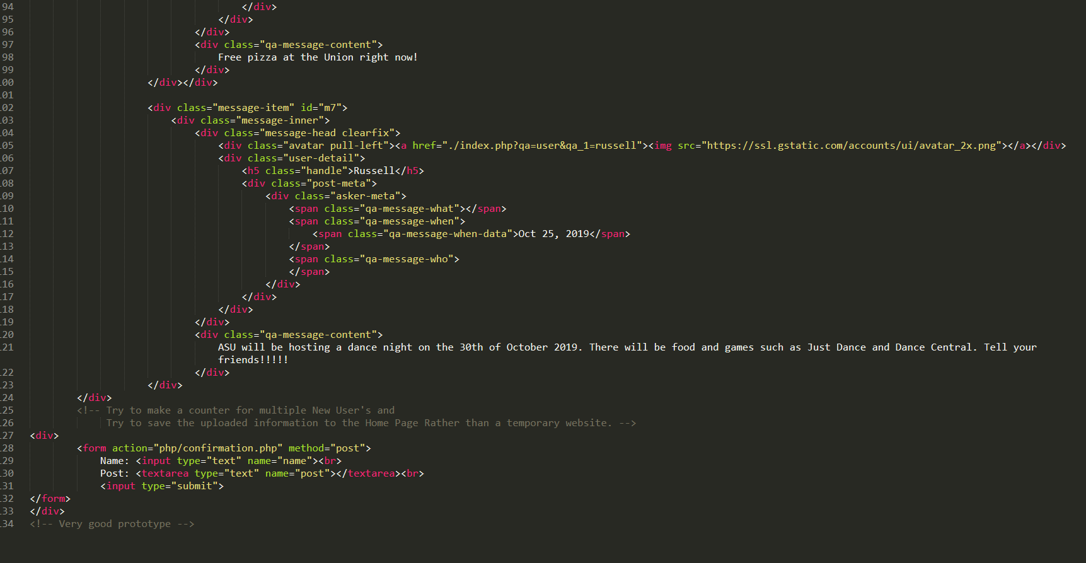**

**Self-check on best practices for security**

The major asset we are trying to protect login credentials. To encrypt the passwords in the database we are going to use php. Therefore, the only inputs that need to be validated are the login credentials. To accomplish this, we will be using php and SQL to validate that the correct information was inputted.

**Self-check: Adherence to original Non-functional specs**

The website’s login and registration page are being worked on: DONE

The website’s home page basic functionality: DONE

The website’s database for profile management is being setup: ON TRACK

The website is working saving all of the information to the Home Page: ON TRACK

**YOUTUBE URL**: [**https://youtu.be/z2rRSmOEZOY**](https://youtu.be/z2rRSmOEZOY)